**House Price Dataset Analysis**

**Figure 1: Sale Price and Overall quality**

Sale prices increase following the quality of the house.

The better the quality, the more expensive the house is.

**Figure 2: Sale Price and Lot size**

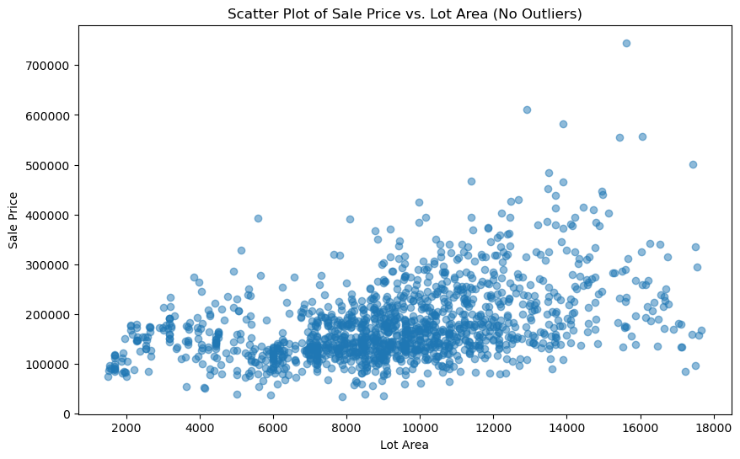

After removing the outliners (some houses have huge lot size), the scatter plot and the correlation coefficient number (0.428) indicates a moderate relation between Sale price and Lot Area. It means the price will likely go up when the lot is bigger.

**Figure 3: Sale Price and Building Age**

The building age seems to have negative impact on the selling price. When it gets older the price become cheaper.

These houses with extremely high price on the market are built within 30 years ago.

**Figure 4: Type of Roof house and Roof material**

* Gable and Hip are the most popular roof styles.
* Composite Shingle is the primary material to build roofs here. Almost 100% Gable and Hip built from Composite Shingle, while other styles has a mixed of Tar & Gravel and other materials.

**Figure 5: Exterior materials and Exterior quality**

Most of the house exterior in Average condition, even some was built with Excellent and Good quality materials.